Image Gallery Software

Use-Case-Realization Specification: Delete Image

Version <1.0>

Revision History

|  |  |  |  |
| --- | --- | --- | --- |
| **Date** | **Version** | **Description** | **Author** |
| 17/12/2020 | <1.0> | <details> | Do Minh Hieu |
|  |  |  |  |
|  |  |  |  |
|  |  |  |  |

Table of Contents

1. Introduction 2

1.1 Purpose 2

1.2 Scope 2

1.3 Definitions, Acronyms, and Abbreviations 2

1.4 References 2

1.5 Overview 2

2. Use-Case Specification 4

3. Interaction Diagrams 5

4. Class Diagrams 2

3. Derived Requirements 2

Use-Case-Realization Specification: Delete Image

# Introduction

## Purpose

This document describes how the Delete Image Use-Case is realized within the design model, in terms of collaborating objects.

## Scope

This document applies to the Image Gallery Software which will be developed Group 5C-18.

## Definitions, Acronyms, and Abbreviations

User – a person who use the software.

## References

None.

## Overview

In the following section, Use-Case Realization Specification of the Delete Image Use-Case of the Image Gallery Software is provided in detail. The first section is a textual description of the Use-Case specification. The following section contains diagrams (sequence and collaboration diagrams) describing how the use case is realized in terms of collaborating objects. The third section includes class diagrams with relationships that participate in the realization of the use case. The last section is an analysis of all requirements, such as non-functional requirements, on the use-case realization that are not considered in the design model, but that need to be taken care of during implementation.

# Use-Case Specification

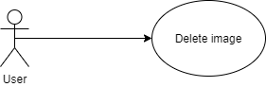

|  |  |
| --- | --- |
| **Name** | Delete Image |
| **Brief Description** | User delete picture |
| **Actor** | User |
| **Flow of Events** | |
| **Basic Flow** | |
| 1. User open the image they posted. 2. Click delete button. 3. The image will be removed from database. 4. Message ‘Image deleted’ is showed. | |
| **Alterante Flows** | |
| **Title** | **Description** |
| None. |  |
| **Pre-Conditions** | |
| Not empty field. | |
| **Post-Conditions** | |
| **Title** | **Description** |
| Success | Success message is prompted and the picture will be deleted immediately. |
| **Extension Points** | |
| None | |

# Interaction Diagrams

**Sequence Diagram:**

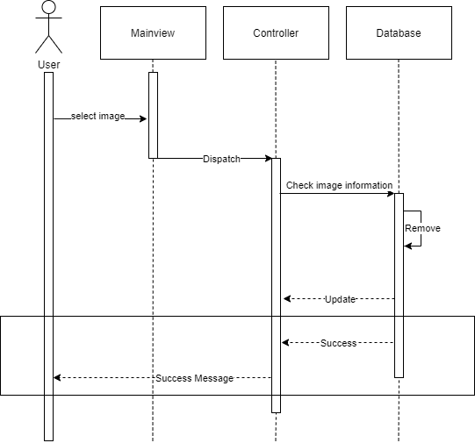

**Collaboration Diagram:** 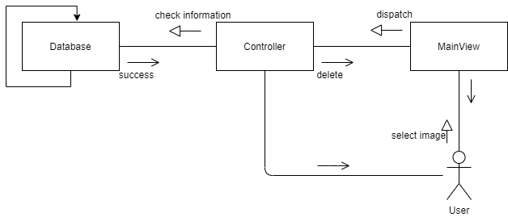

# Class Diagrams

# 

# Derived Requirements

None.